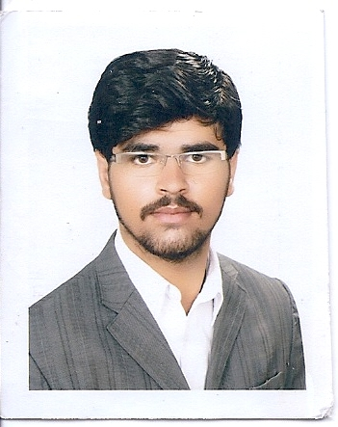
Muhammad Shah Nawaz

Address : Peshawar

Cell no :

03,
03078028303

Email Address: shahnawaz20133@gmail.com

Data of birth: 16
th

Oct 1997

Professional Summary

Solution-driven Web developer adept at contributing to highly collaborative work environment, finding solutions and determining customer satisfaction. Proven experience developing consumer-focused websites using HTML, CSS, BOOTSTRAP, JQUERY, PHP and JavaScript.

Academic Record

2016 TO 2019 BS Computer Science
Department CS/IT (ICS) Agriculture University Peshawar Pakistan
Got CGPA of 3.54/4.0
• Carried out the studies of 45 subjects, mostly occupied with programming languages (OOPs), Soft Engineering, Artificial Intelligence, Database, Assembly Language, Computer Architecture, Algorithm Analysis and Design, Network and System Security, Discrete Math, Digital Logic and Design and Computer graphics etc.

2013 TO 2015 FSc ( Pre Engineering)
Govt Post Graduated College Parachinar Pakistan

• Learned all Pre-Engineering concepts and learned to solve through these concepts in future.

2011 TO 2013 Matric (Science)
Allama Iqbal Public School Parachinar Pakistan
• Studied Science subjects to use these concepts into real world problem.

Technical Proficiency

- Programming Languages: C++, OOP,PHP also advance php
- Web Development: PHP,CSS, SCSS,SASS,HTML5, JQUERY, BOOTSTRCIPT,WORDPRESS,DRUPAL 8(CMS)
- Application: MS office
- Operating System: Windows
- Projects: Online shopping projects & also prepared one project for company name digital forest.
- Nowadays :I am doing or working on Drupal 8(CMS) at NetChain Media Software Company as a internship form September 2020 yet.

2020-09 - Current

Work History:

Web Developer (Internship, Peshawar, Pakistan)

- Planned website development, converting mockups into usable web presence with HTML, Css, Scss, Bootstrap, Jquery, php, JavaScript, and Drupal8(CMS)
- Provided front-end website development using DRUPAL8, and other editing software.

Semester project

- Human Resources Management System(HRMs)

Hobbies and Interests

- Football, Badminton, Tennis,Volleyball
- Walking
- Reading Newspaper

Professional strengths

- Well presenter and good communication skills
- Understand the value of time and good skills of time management
- Quick learner and ability to work under pressure
- Good motivator, enthusiastic and open to learn new ideas
- Punctual, Hard worker

Workshop/Training/Award

- Participated Haidri Blood and Welfare Society.
- Laptop awarded by Prime minister’s laptop Scheme on merit
- 50% GPA based Scholarship from University

Language detail

Language | Read | Write | Speak
English | Fluent | Fluent | Fluent
Urdu | Advanced | Advanced | Advanced
Pashto | Advanced | Advanced | Advanced

